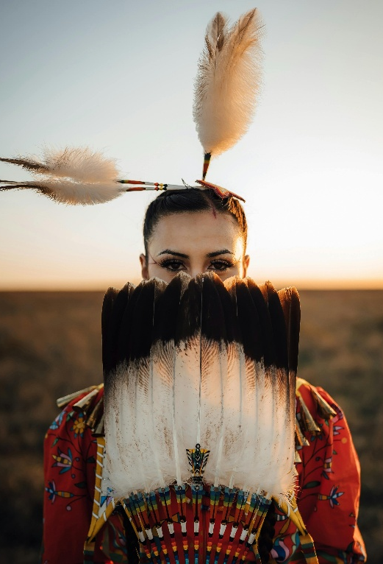
THINK PIECE
Reclaiming Identity: What is this thing called gender?
By Kizzann Sammy, MA, MBA
What if our understanding of gender is not universal, but shaped by history, culture, and power?
I've been exploring how European colonial systems often imposed rigid gender norms rooted in Christian and patriarchal traditions. Through missionary activity, legal systems, residential schools, and other institutions, these norms frequently marginalized Indigenous understandings of gender and social roles. These structures were not simply cultural differences; they were often part of broader projects of governance and control that reshaped societies and defined certain ways of being as "civilized" while dismissing others as "primitive" or "savage."
Indigenous cultures offer important perspectives that challenge the assumption that binary gender systems are universal.
Photo credit: Cody Hammer
Across Turtle Island and in many Indigenous societies around the world, diverse understandings of gender have existed for generations. While beliefs and practices varied among nations and communities, many cultures recognized social, spiritual, and ceremonial roles that extended beyond colonial male/female categories. Identities such as Two-Spirit, muxhe, and whakawahine reflect distinct cultural traditions that demonstrate gender diversity is not a new phenomenon, but one with deep historical roots.
It is important to recognize that these identities are not interchangeable. Two-Spirit is a contemporary Indigenous term that encompasses diverse Indigenous understandings of gender and sexuality across North America, while muxhe and whakawahine emerge from their own unique cultural contexts in Mexico and Aotearoa (New Zealand). Together, they illustrate that human experiences of gender have long been more varied than has promoted “as normal” by many contemporary Western frameworks.
In some Indigenous communities, gender-diverse people held important social, ceremonial, or spiritual responsibilities and were accorded significant respect. Although experiences differed across cultures and historical periods, the existence of these roles challenges the idea that gender diversity is a recent development.
Colonization disrupted many of these systems. Across the globe, European colonial powers frequently replaced Indigenous social structures with institutions shaped by Christian doctrine, patriarchal hierarchies, and racialized systems of governance. The effects of these policies can still be seen today in social institutions, laws, and ongoing public debates about gender, identity, and belonging.
Moving forward requires more than inclusion. It requires examining how ideas of "normal" are constructed and whose perspectives have historically been privileged in that process.
Centering Indigenous knowledge does not require rejecting all binary understandings of gender. Rather, it challenges the assumption that binary frameworks are universal, natural, or the only way societies have understood human identity. Indigenous histories remind us that more diverse and inclusive ways of understanding gender have existed and continue to exist.
It is fitting that June is both Pride Month and National Indigenous History Month in Canada. National Indigenous Peoples Day, observed on June 21, coincides with the summer solstice, a time of deep cultural and spiritual significance for many Indigenous peoples.
As we reflect on these connections, one must consider a broader question: How have history, culture, and power shaped our understanding of gender, and what might we learn from Indigenous perspectives as we imagine more inclusive futures?
What are your thoughts on the relationship between gender, culture, and Indigenous knowledge?
This think piece is based on the opinions, research and findings of the author, and may not reflect the overall position of Kochi Consulting Ltd. and / or its affiliates. Interested in submitting a think piece to our team? Contact admin@kochiconsulting.com.

References
Banet-Weiser, S. (2018). The politics of visibility: Gender, race, and corporations in the public sphere. Feminist Media Studies, 18(4), 551–565.
Davis, A. (1981). Women, race & class. Random House.
Nanda, S. (1999). Neither man nor woman: The Hijra of India. Wadsworth Publishing.
Roscoe, W. (1998). The Zuni man-woman. University of New Mexico Press.
Williams, W. L. (1992). Two-spirit people: Native American gender identity, sexuality, and spirituality. University of Illinois Press.
National Centre for Truth and Reconciliation. (2013). The history of residential schools.

